**Task 1**

#include<iostream>

using namespace std;

int main() {

int ar[5], product;

cout << "enter values of array : ";

for (int i = 1; i <= 5; i++) {

cin >> ar[i];

cout << endl;

}

for (int i = 1; i <= 5; i++) {

for (int j = 1; j <= 10; j++) {

product = ar[i] * j;

cout << product << " ";

}

cout << endl;

}

return 0;

}

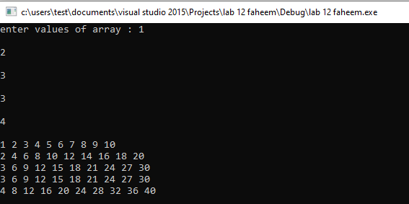

**Task 2**

#include<iostream>

#include<time.h>

using namespace std;

int main() {

srand(time(0));

int ar[200], j=0;

for (int i = 1; i <= 200; i++) {

ar[i] = rand() %100;

}

for (int i = 1; i <= 200; i++) {

cout << ar[i] << " ";

j++;

if (j % 10 == 0) {

cout << endl;

}

}

system("pause");

}

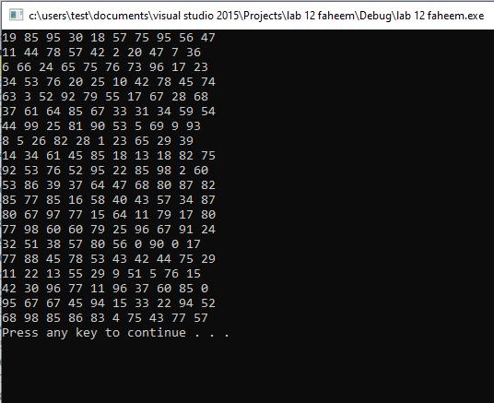

**Task 3**

#include<iostream>

using namespace std;

int main() {

int ar[10], num, count=0;

cout << "enter number for search ";

cin >> num;

cout <<endl<< "enter values of array : ";

for (int i = 1; i <= 10; i++) {

cin >> ar[i];

if (ar[i] == num) {

count++;

}

}

if (count != 0) {

cout << "searched number is found " << count << " times ";

}

else {

cout << "searched number not found ";

}

system("pause");

}

**Task 4**

#include<iostream>

using namespace std;

int main() {

int ar[10], element, index;

cout << "enter values array : ";

for (int i = 0; i < 9; i++) {

cin >> ar[i];

}

cout << "{";

for (int i = 0; i < 9; i++) {

cout << ar[i] << "," ;

}

cout << "}";

cout << endl << "enter 10th element";

cin >> element;

cout << "enter index" << endl;

cin >> index;

for (int j=10; j > index; j--) {

ar[j] = ar[j - 1];

}

ar[index] = element;

cout << "{";

for (int i = 0; i < 10; i++) {

cout << ar[i] << "," ;

}

cout << "}";

system("pause");

}

